Ticketing Log

# **Overview:**

* [G5T7] SCP 1.2.0 Product Update
* [G5T7] Security Enhancement for SCP
* [G5T7] Ransomware attack on SCP Google Slide 2

# **[G5T7] SCP 1.2.0 Product Update**

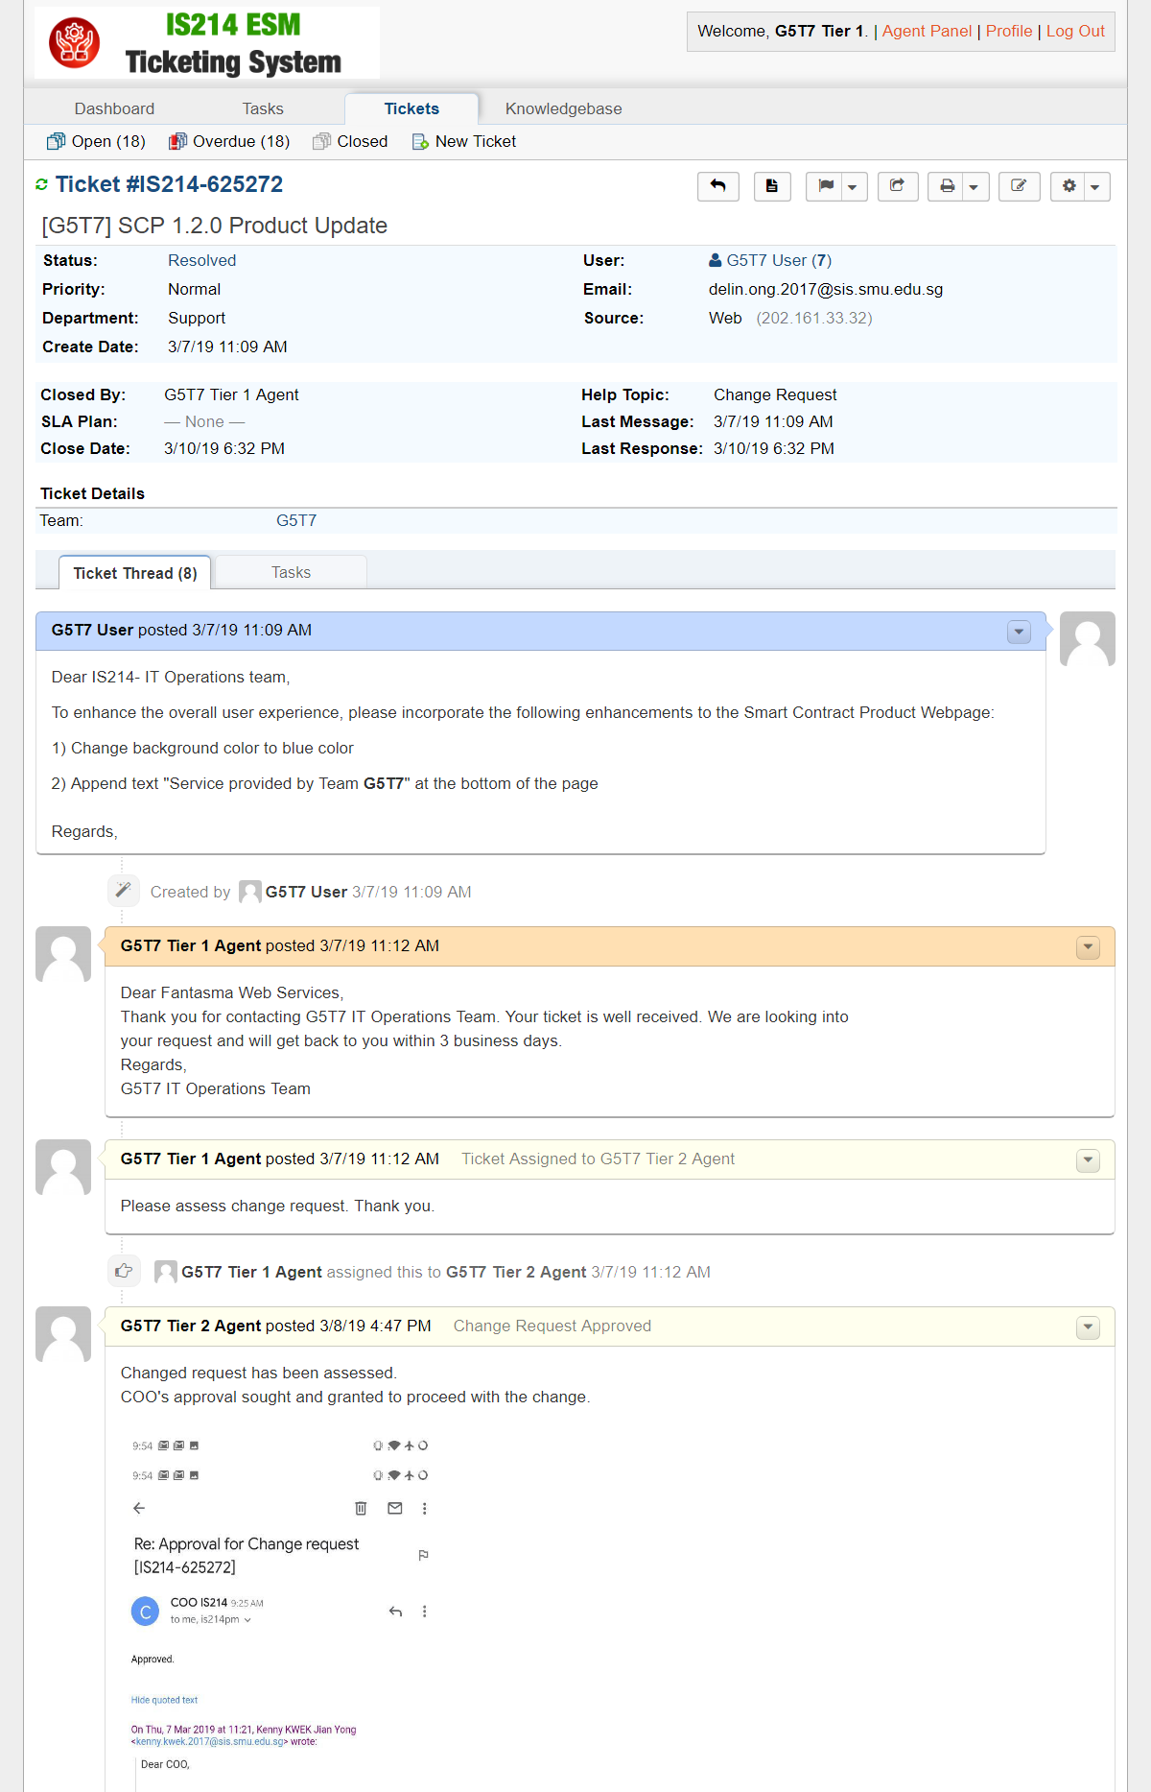

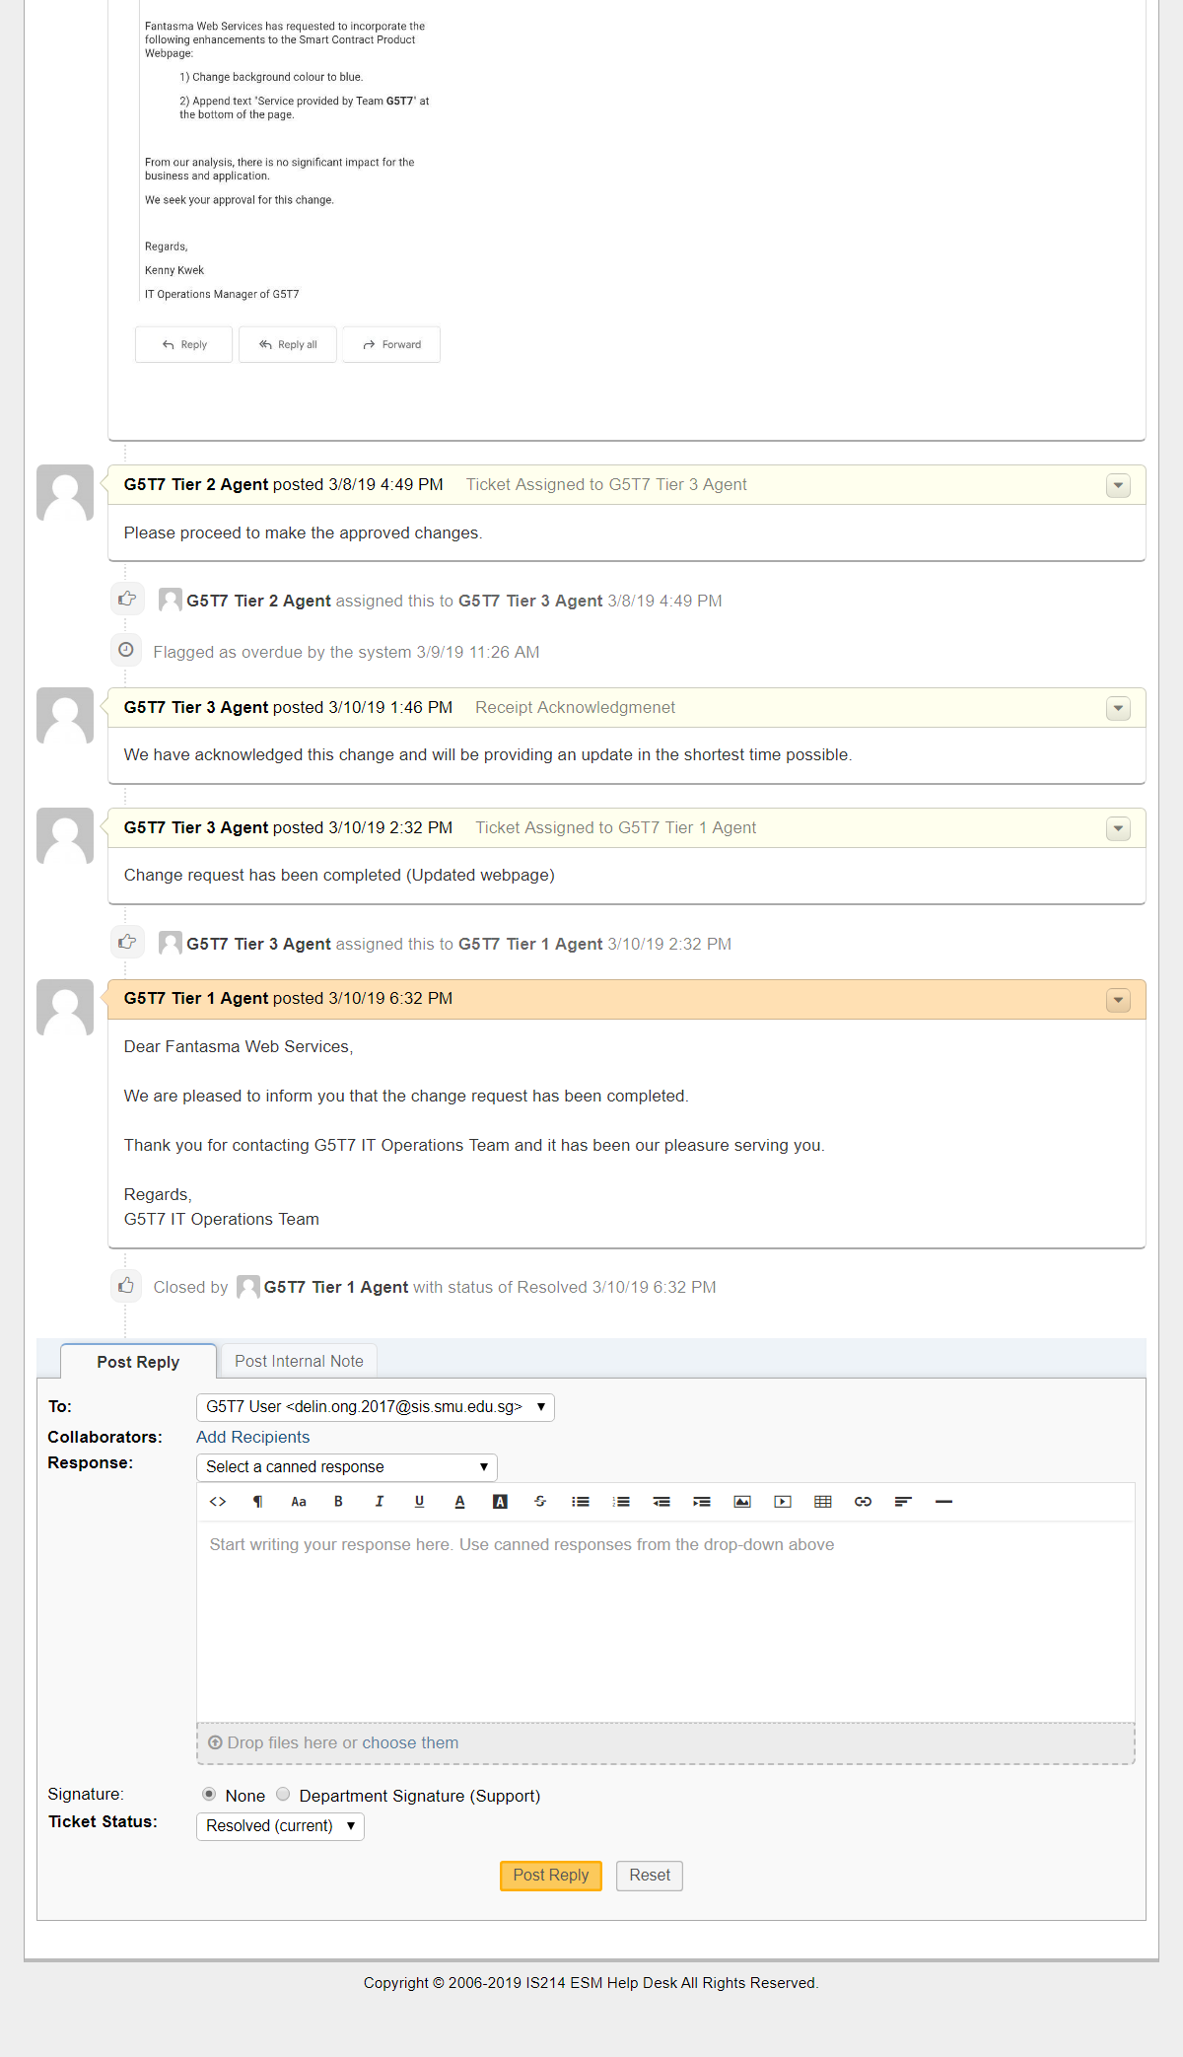

# **[G5T7] Security Enhancement for SCP**

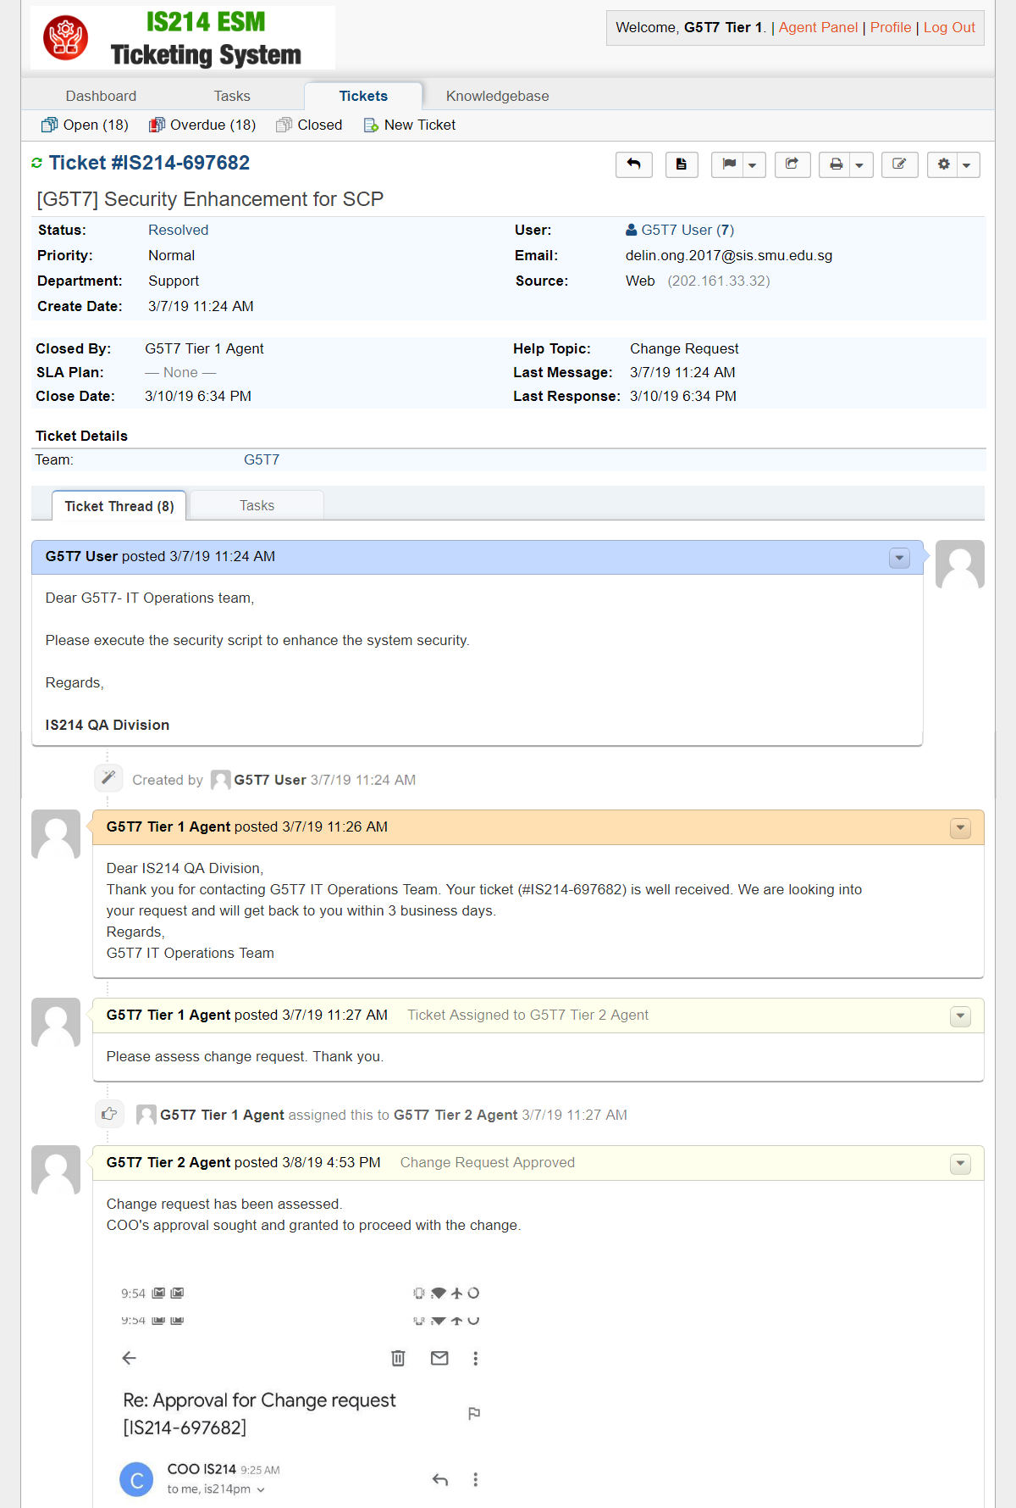

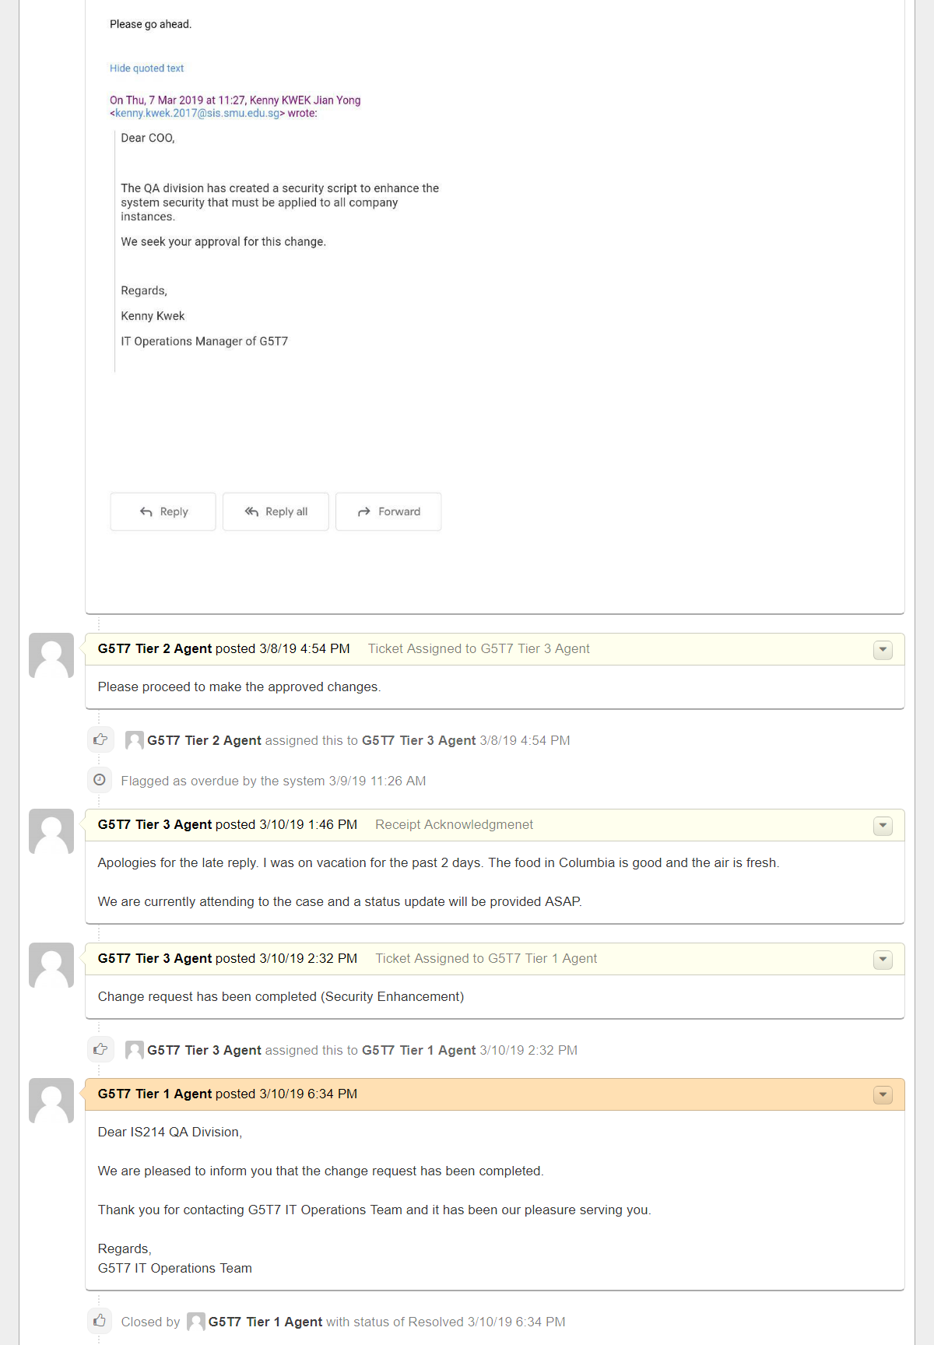

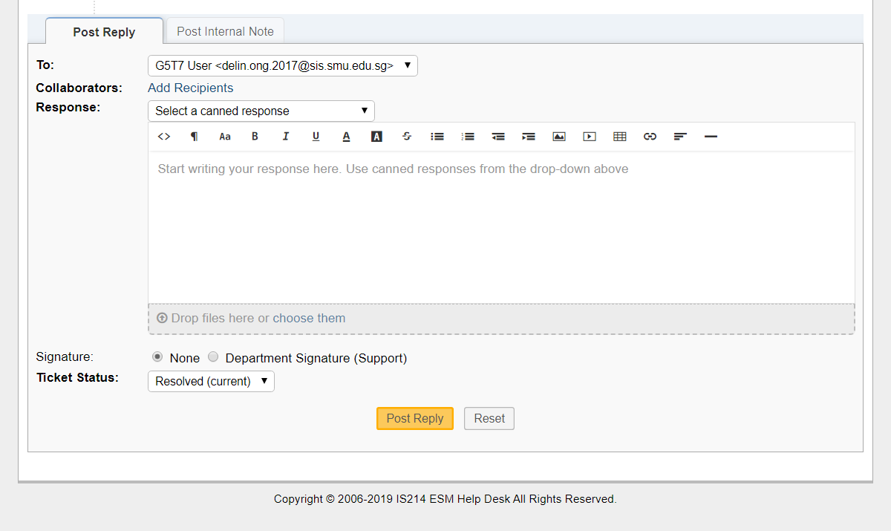

# **[G5T7] Ransomware attack on SCP Google Slide 2**

